More about topics

Docker
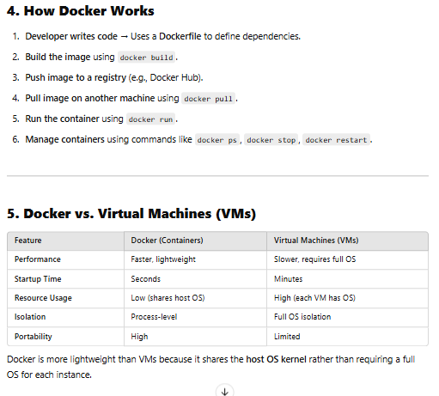
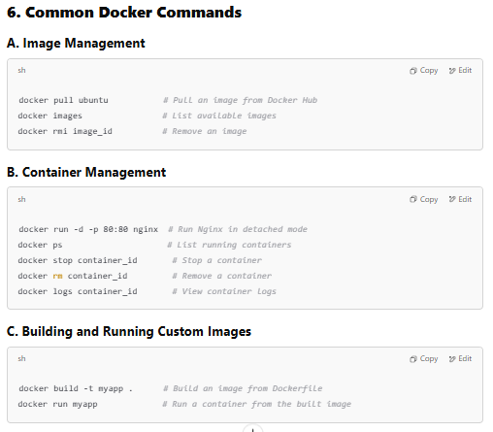
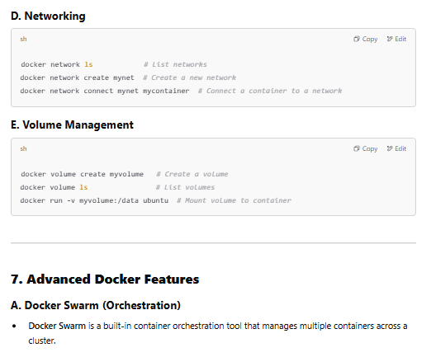
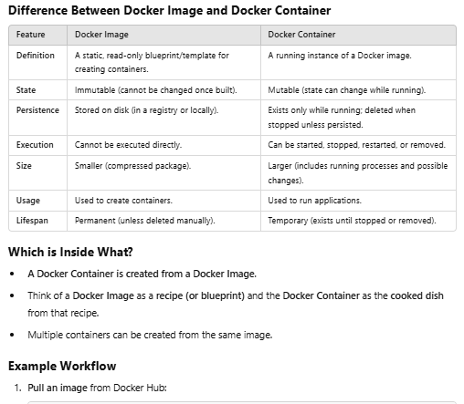
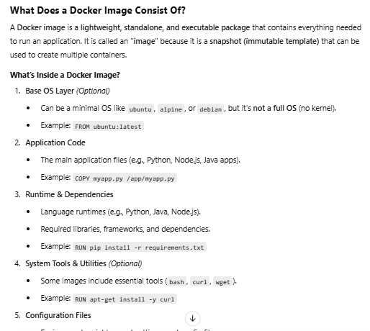
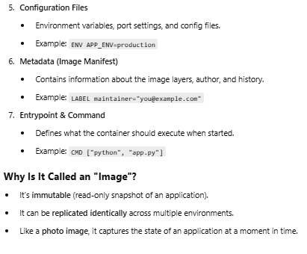
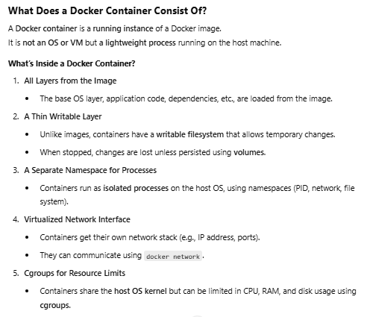
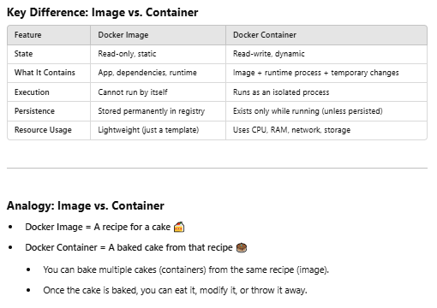
Lma a7awl a access mn Jenkins ashof l docker images hydeny denied 34an lsa mrbthomsh b b3d
So we have to add Jenkins user to the docker group 34an ybd2 yrf3 mno l artifacts 34an ybuild l img
Kda 3mlna add
Life cycle
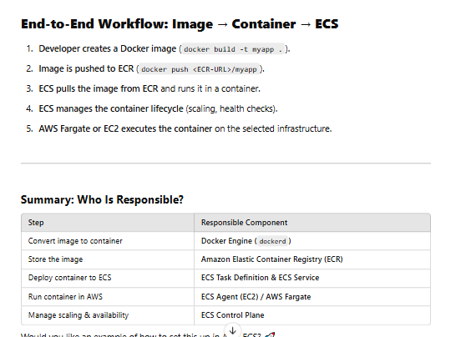
And note that fargate manages all network between instances and other containers w bt manage l comp. resources w kol haga bt3ml hya l instances mzbota w tzbtha hya m3 nfsha automatically 3la 7sb l by7sl w m7tago
Msh eni kol shwya a5osh azbt l config sg w autoscaling w CPUs w m3rfsh eh la hya m3 nfsha zbtt
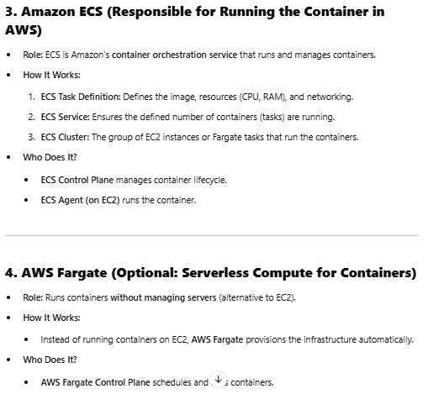
Credentials for docker
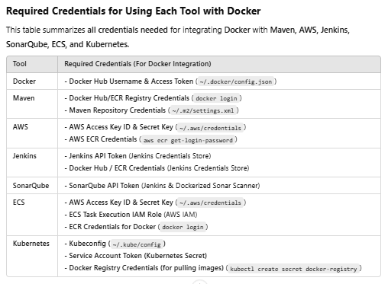
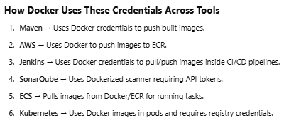

Ansible
Yum da hwa l module
Mn l a5r l inventory da hwa l properties bt3t l machine l l ray7lha, fa l modules b2a wazeftha enha mt5zn feha kol machin b properties bt3tha l mfrod eh l commands l ttama4a m3aha w tt3aml fa msln bnst5dm red hat os fa lma hagy a5od module ha5od l module bta3 l os l folany da l feh yum msln bss

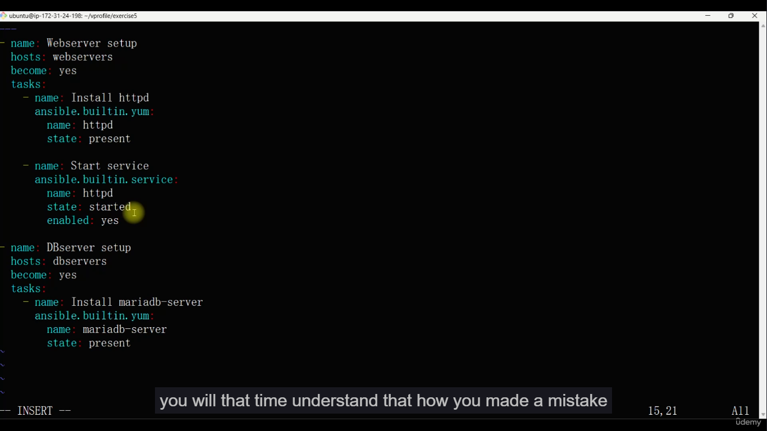
Wna bktb l play book ab2a 3arf en kda ana katb kza playbook f b3d
Y3ni ll webserver w ll db f b3d
Name > esm l play
Host > l server name
Become > yes 34an l root user
Tasks b2a gowaha l modules
Awl haga name l task
B3dha l module l ana h3mlo fa hdelo esm l haga l y3mlha w state bt3tha ehh
W b3dha momkn aktb task gdeda b esm module gded w hakza
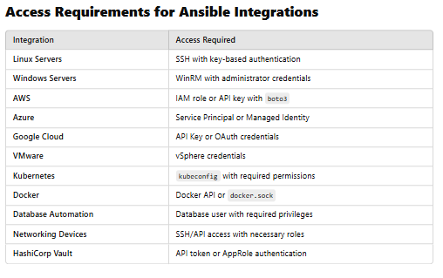
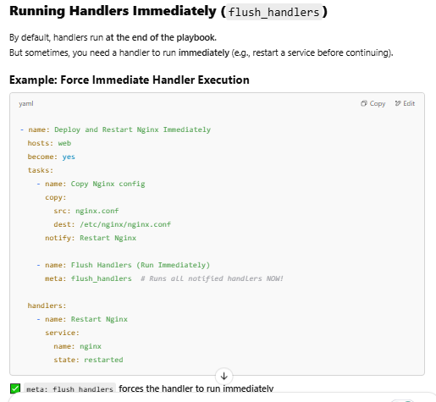
✅ meta: flush_handlers forces the handler to run immediately
✅ Useful when a task depends on a restarted service

Kubernetes
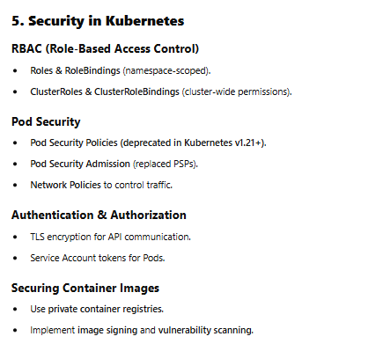
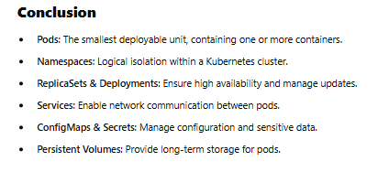
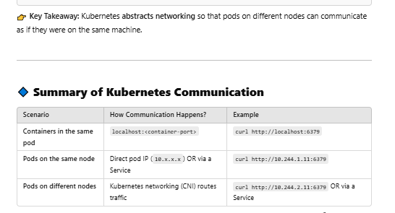

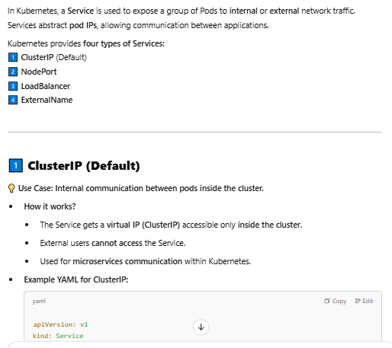
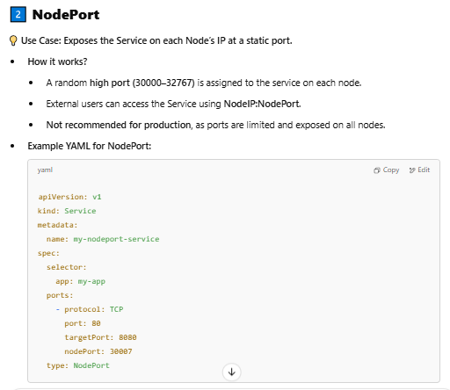
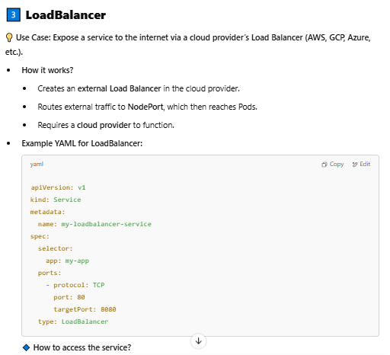

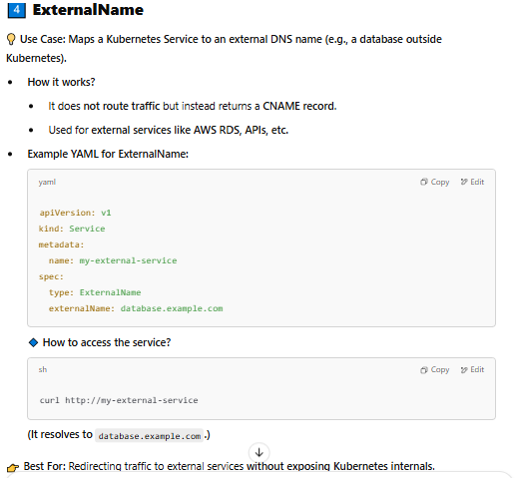
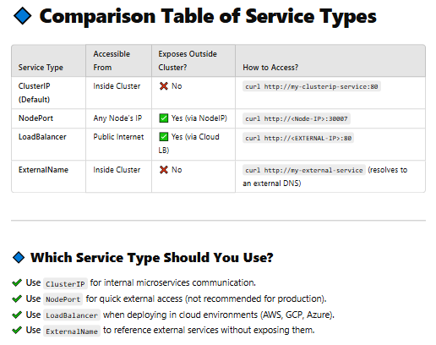

what is the difference between creating replicas from object kind deployment and kind replica set?
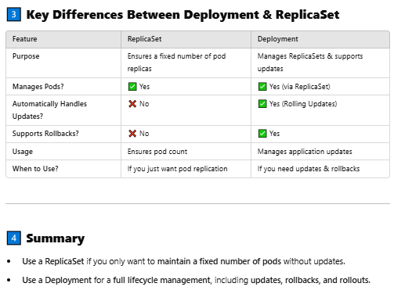

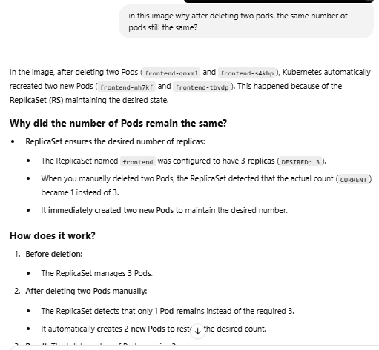

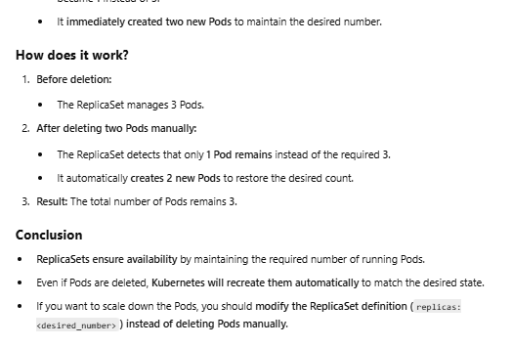

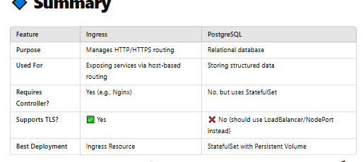

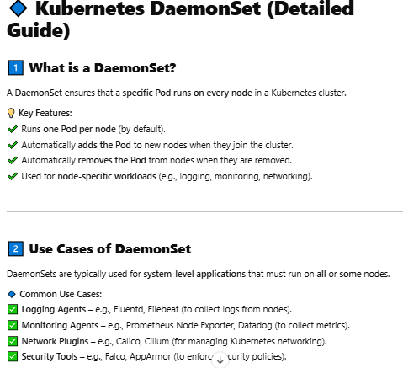

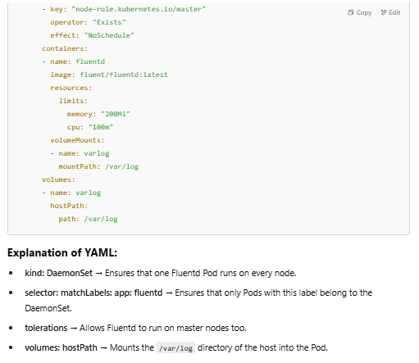

Btb2a en msln lazm pod mo3ynaa tkon run 3la kolo
Y3ni no3 mo3yn mn l pods lazm ykon mwgod f kolo
Zi msln security w montioring w kda lazm yb2a kol l nodes tb2a monitored w secured akid fa awl ma l pod l security de tt3ml fa hya byro7 y7otha f kol l nodes l fl cluster mra wa7da

